CS33101 – Structure of Programming Languages
Homework 1: Add an operator
2/15/2026
Yusairah Haque
- Changes and additions made to tokenizer.py
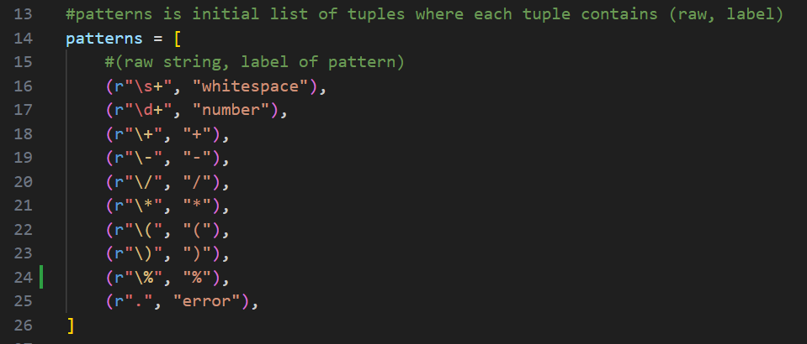
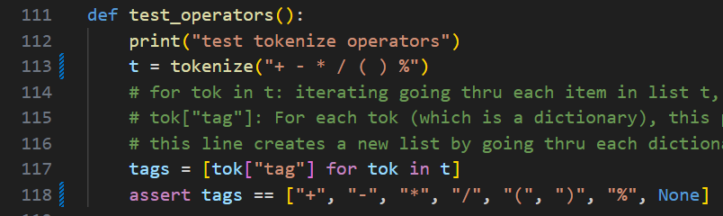
Added test cases in def test_expression()
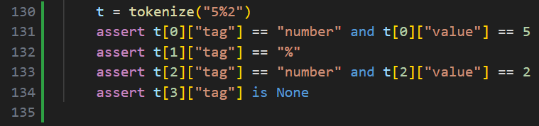

- Changes and additions made to parser.py
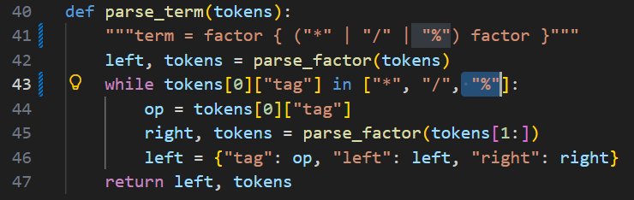
Added test cases in def test_parse_term()
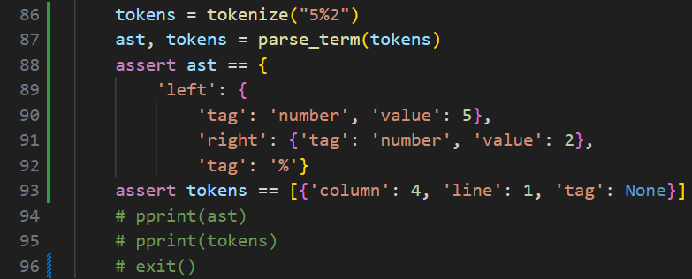
- Changes and additions made to evaluator.py
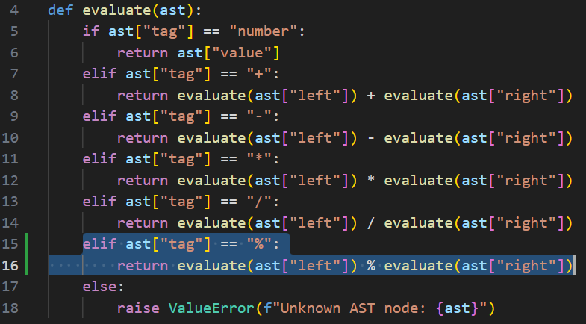
Added test cases in def test_evaluate()
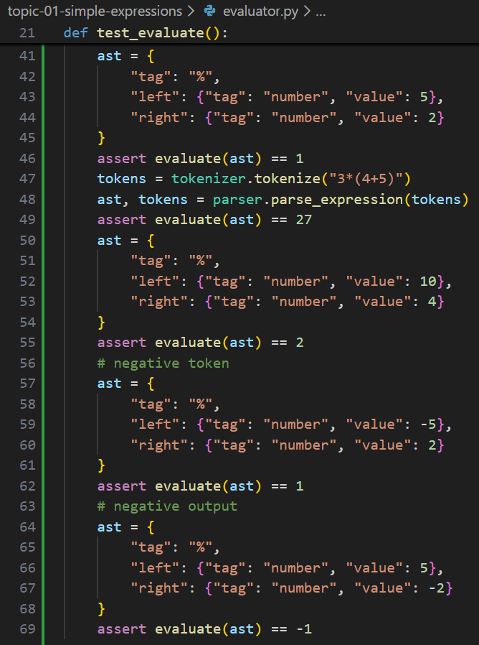
- Outputs of some % expressions with the runner.py 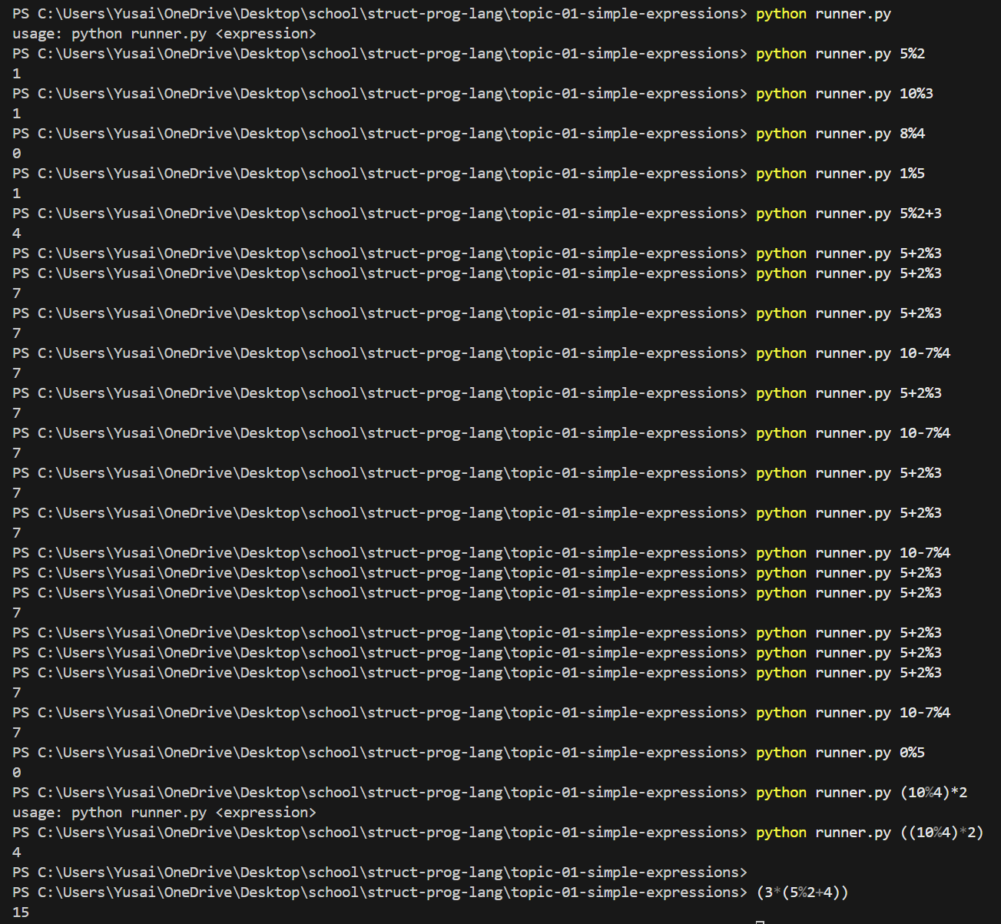
Note: Negative numbers do not go through in terminal (“python runner.py -5%2” will return error), because our grammar does not include unary minus. Our language only understands numbers, parentheses, binary operators. I wrote AST negative test cases in the code to test the modulo operator.

